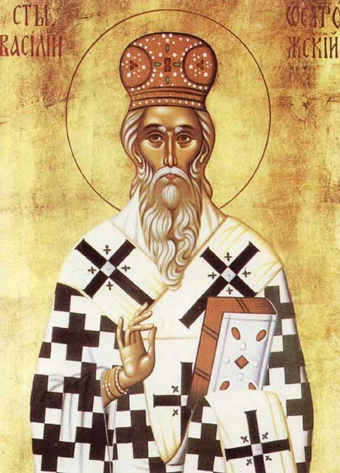
St. Basil of Ostrog
27450 North Bradley
Lake Forest, IL 60045
847-247-0077
www.stbasilchurch.org
NOTES
Coffee with a little Stewardship

Menu
March 29, 2015
The Fifth Sunday of Lent - St. Mary of Egypt
Our holy mother Mary was born in Egypt. She had left her parents at the age of twelve to go to Alexandria, where she spent the next seventeen years in debauchery and the greatest profligacy. One day, seeing a crowd of Lybians and Egyptians moving towards the port, she followed them and set sail with them for Jerusalem, offering her body to pay her fare. When they arrived in the Holy City, she followed the crowd that was thronging towards the Church of the Resurrection, it being the day of the Exaltation of the Cross. But, when she reached the threshold of the church, an invisible force prevented her entering in spite of repeated efforts on her part, although the other pilgrims were able to go in without hindrance. Left alone in a corner of the narthex, she began to realize that it was the impurity of her life that was preventing her approaching the holy Wood. She burst into tears and smote her breast and, seeing an icon of the Mother of God, made this prayer to her: "O Sovereign Lady, who didst bear God in the flesh, I know that I should not dare to look upon thine icon, thou who are pure in soul and body, because, debauched as I am, I must fill thee with disgust. But, as the God born of thee became man in order to call sinners to repentance, come to my aid! Allow me to go into the church and prostrate before His Cross. And, as soon as I have seen the Cross, I promise that I will renounce the world and all pleasures, and follow the path of salvation that thou willest to show me."
She felt herself suddenly freed from the power that had held her and was able to enter the church. There she fervently venerated the Holy Cross and then, returning to the icon of the Mother of God, declared herself ready to follow the path that the Virgin would show her. She then lived from that time on in the desert, remaining there for forty-seven years without ever encountering either another human being or any animal.

Stewardship - Care for the family Altar.
The family Altar establishes an area that is dedicated to prayer and reflection. This may simply include an icon on the east wall of a room, or a small table for icons, vigil lights and incense. Please refer to Making God Real in the Orthodox Christian Home by Father Anthony Coniaris – page 93 - for additional details.

The
Stewardship Introduction
This week’s take aways…
The family Altar is a special place within the home. It replicates the Church as is a reminder hat God is with us always. Do you have a family Altar? Are there icons throughout your home? Visit your Church’s bookstore to purchase what you need.

Develop a daily habit of morning and evening prayers in front of your family Altar. This is a place of peace and reflecton within your home. Encourage all of your family members to do this as well.

When your priest visits for a home blessing, place the bowl for Holy Water, the censer and the icons on your family Altar table.

